OOPS LAB 2
Hania Imran
25K-0523
Task1:
#include<iostream>
#include<fstream>
#include<string>
using namespace std;

struct Player
{
string name;
int homeRuns;
int hits;
};

void input(Player p[],int n)
{for(int i = 0; i < n; i++)
{
cout<<"\nEnter name:";
cin>>p[i].name;
cout<<"Enter home runs:";
cin>>p[i].homeRuns;
cout<<"Enter hits:";
cin>>p[i].hits;
}
}

void display(Player p[],int n)
{for(int i=0;i<n;i++)
{ cout<<"\nName:" <<p[i].name;
cout<<"\nHome runs:"<<p[i].homeRuns;
cout<<"\nHits:"<<p[i].hits<<endl;
}}

void searchUpdate(Player p[],int n)
{string key;
cout<<"\nEnter name to search:";
cin>>key;
for(int i=0;i<n;i++)
{if(p[i].name==key)
{ cout<<"Enter new home runs:";
cin>>p[i].homeRuns;
cout<<"Enter new hits:";
cin >> p[i].hits;
return;}}
cout << "Player not found!\n";}

void save(Player p[],int n)
{ofstream f("players.txt");
for(int i = 0; i < n; i++)
f << p[i].name <<" "<<p[i].homeRuns<<" "<<p[i].hits<<endl;
f.close();
cout<<"Saved to file.\n";}

int main()
{Player p[3];
int choice;
input(p,3);
do{
cout<<"\n1. Display";
cout<<"\n2. Search & Update";
cout<<"\n3. Save to file";
cout<<"\n4. Exit";
cout<<"\nChoice: ";
cin>>choice;
if(choice==1)
display(p,3);
else if(choice==2)
searchUpdate(p,3);
else if(choice==3)
save(p,3);}
while(choice!=4);
return 0;
}

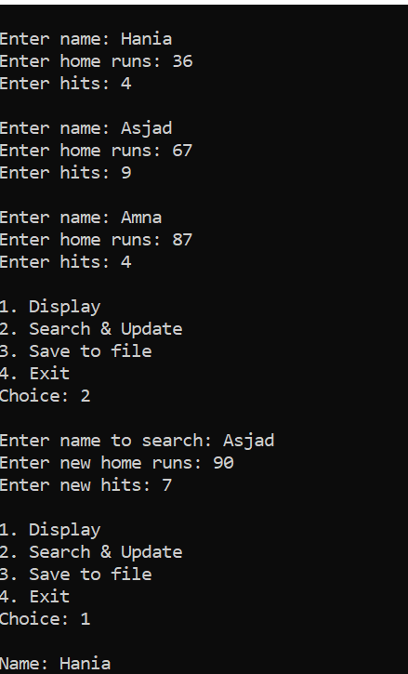
Task2:
class Date
{int year;
int month;
int date;
public:
void setdate(int d);

void setmonth(int m);

void setyear(int y);

void displaydate();
};

#include"Date.h"
#include<iostream>
using namespace std;
void Date::setdate(int d)
{if(d>31 && d<1)
cout<<"Error";
else
date=d;
}
void Date::setmonth(int m)
{if(m>12 && m<1)
cout<<"Error";
else
month=m;
}
void Date::setyear(int y)
{year=y;
}
void Date::displaydate()
{string mon[12]={"January", "February"," March", "April", "May", "June", "July"," August", "September", "October", "November"," December"};
string ch;
cout<<month<<"/"<<date<<"/"<<year<<endl;
for(int i=0;i<12;i++)
{if(month==i+1)
ch=mon[i];}
cout<<ch<<" "<<date<<", "<<year<<endl;
cout<<date<<" "<<ch<<" "<<year;

}

#include"Date.h"
#include<iostream>
using namespace std;
int main()
{int month,date, year;
Date d;
cout<<"Enter date:";
cin>>date;
cout<<"Enter month:";
cin>>month;
cout<<"Enter year:";
cin>>year;
d.setdate(date);
d.setmonth(month);
d.setyear(year);
d.displaydate();
}

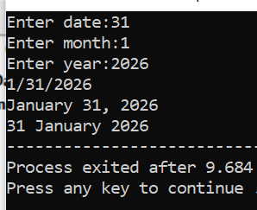
Task3:
#include<iostream>
using namespace std;
class Person{
string name;
int age;
bool gender;
string occupation;
bool cook;
public:
void setname(string n);

string getname();

int getage();

void setage(int a);

void ismale(char g);

bool getmale();

void setocc(string o);

string getocc();

void setcook(char y);

bool getcook();

};

#include<iostream>
#include"Person.h"
using namespace std;
void Person::setname(string n)
{name=n;
}
string Person::getname()
{return name;
}
int Person::getage()
{return age;
}
void Person::setage(int a)
{age=a;
}
void Person::ismale(char g)
{if(g=='M')
gender=true;
else
gender=false;
}
bool Person::getmale()
{return gender;
}
void Person::setocc(string o)
{occupation=o;
}
string Person::getocc()
{return occupation;
}
void Person::setcook(char y)
{if (y=='Y')
cook=true;
else
cook=false;
}
bool Person::getcook()
{return cook;
}

#include<iostream>
#include"Person.h"
using namespace std;
int main()
{Person p1;
p1.setname("Hania");
p1.setage(19);
p1.ismale('F');
p1.setocc("dentist");
p1.setcook('Y');
cout<<p1.getname()<<endl;
cout<<p1.getage()<<endl;
cout<<(p1.getmale()?"True":"false")<<endl;
cout<<p1.getocc()<<endl;
cout<<(p1.getcook()?"True":"false")<<endl<<endl;
Person p2;
p2.setname("Asjad");
p2.setage(21);
p2.ismale('M');
p2.setocc("Banker");
p2.setcook('N');
cout<<p2.getname()<<endl;
cout<<p2.getage()<<endl;
cout<<(p2.getmale()?"True":"false")<<endl;
cout<<p2.getocc()<<endl;
cout<<(p2.getcook()?"True":"false")<<endl;
return 0;
}
